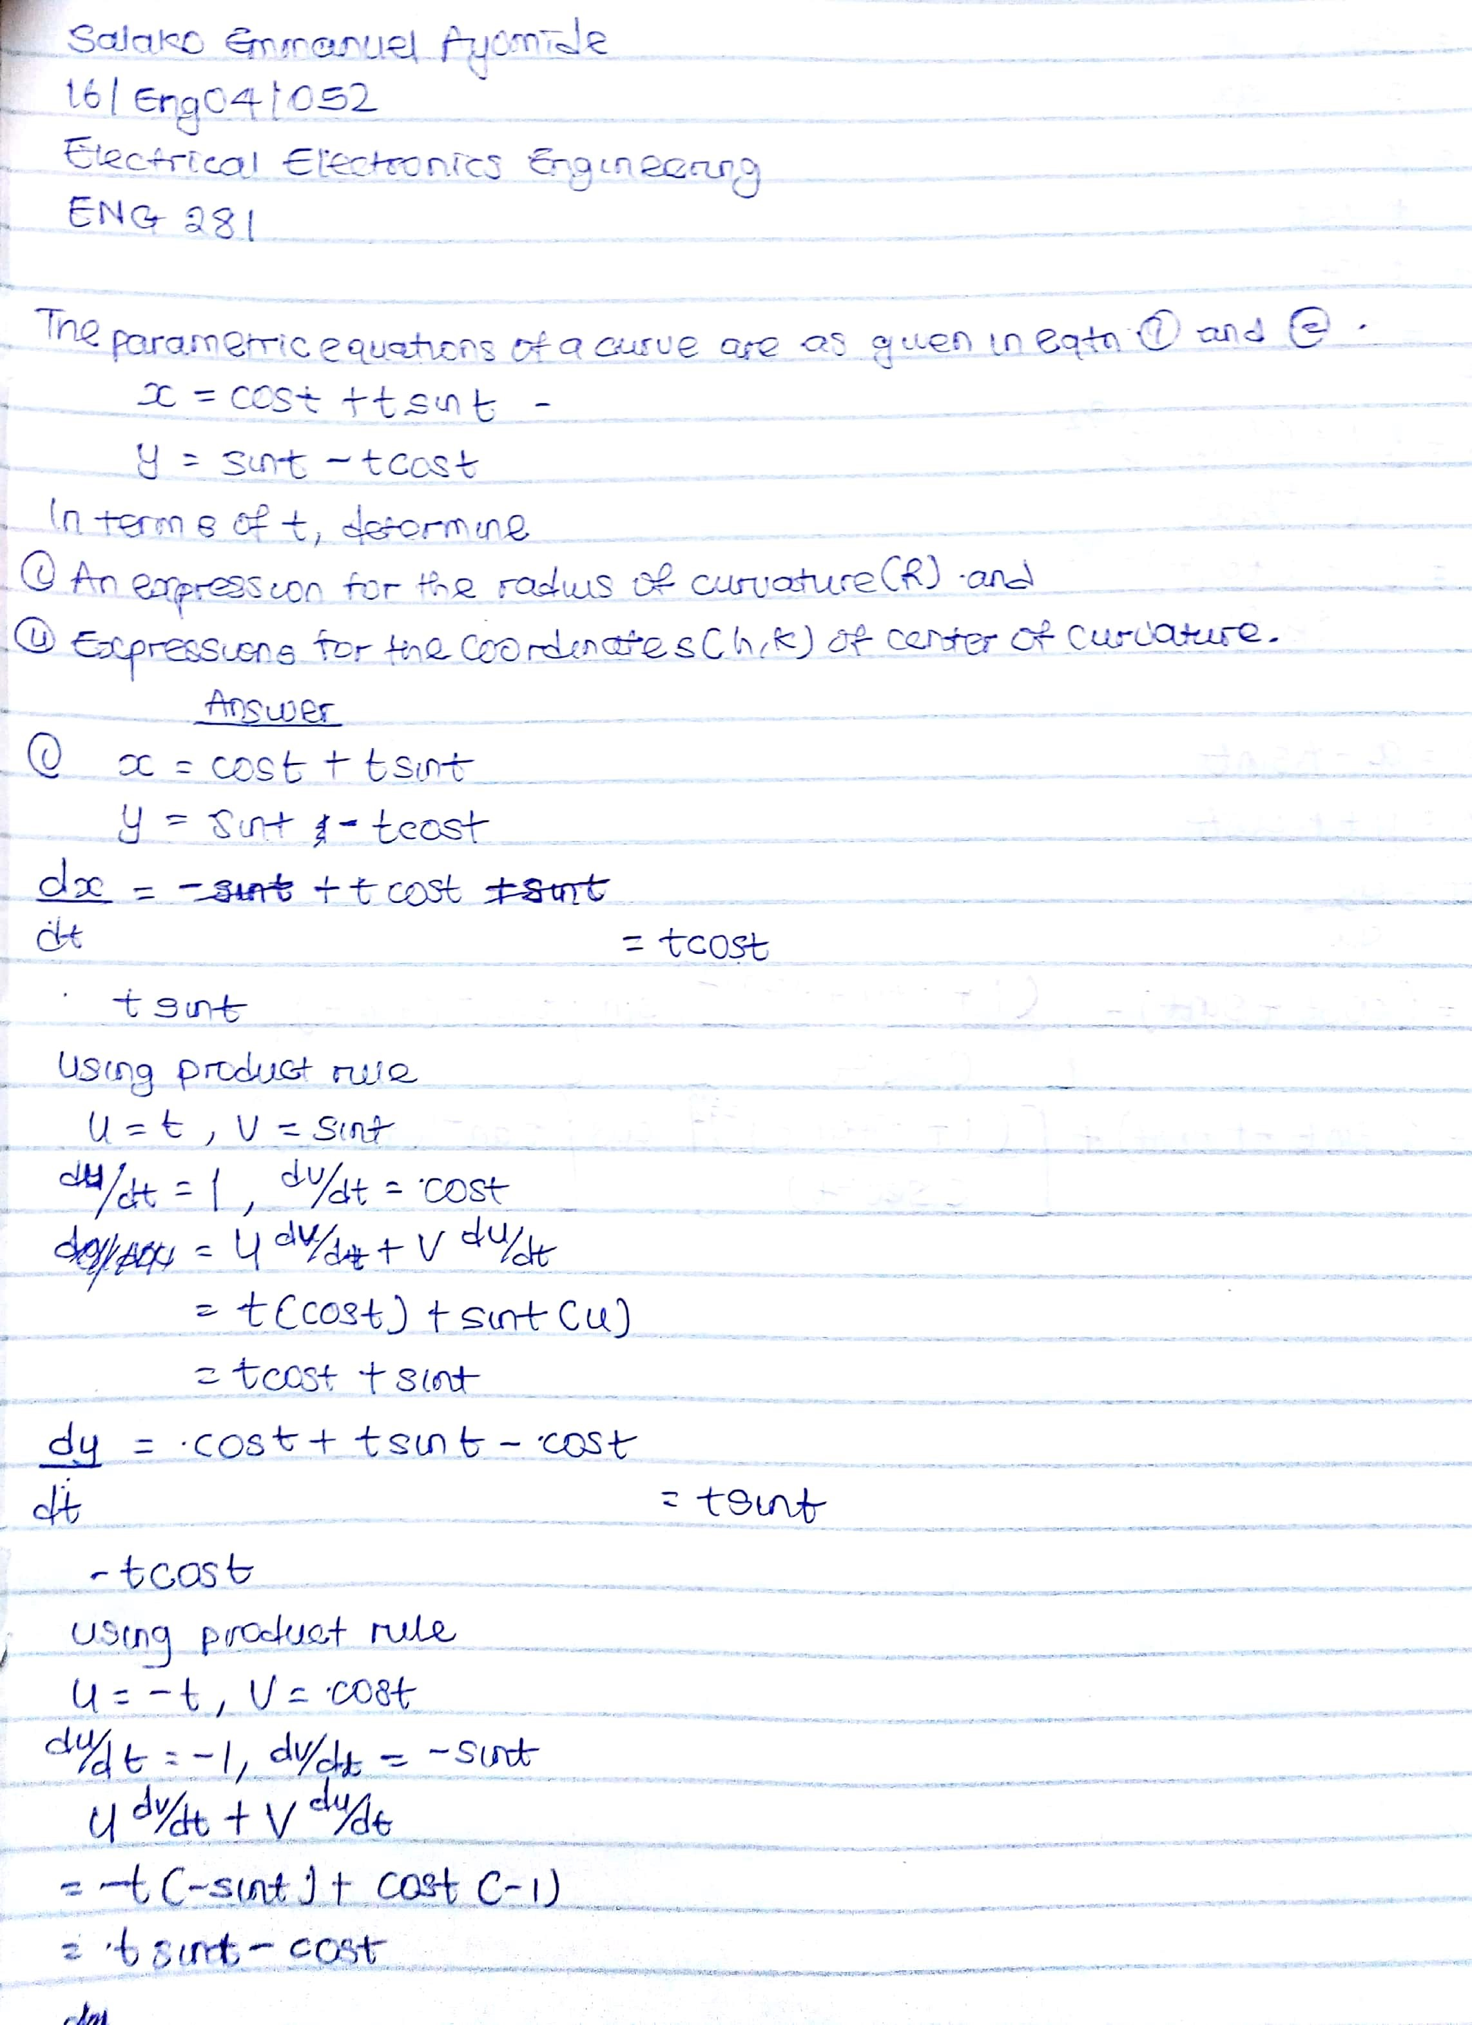
SALAKO EMMANUEL AYOMIDE
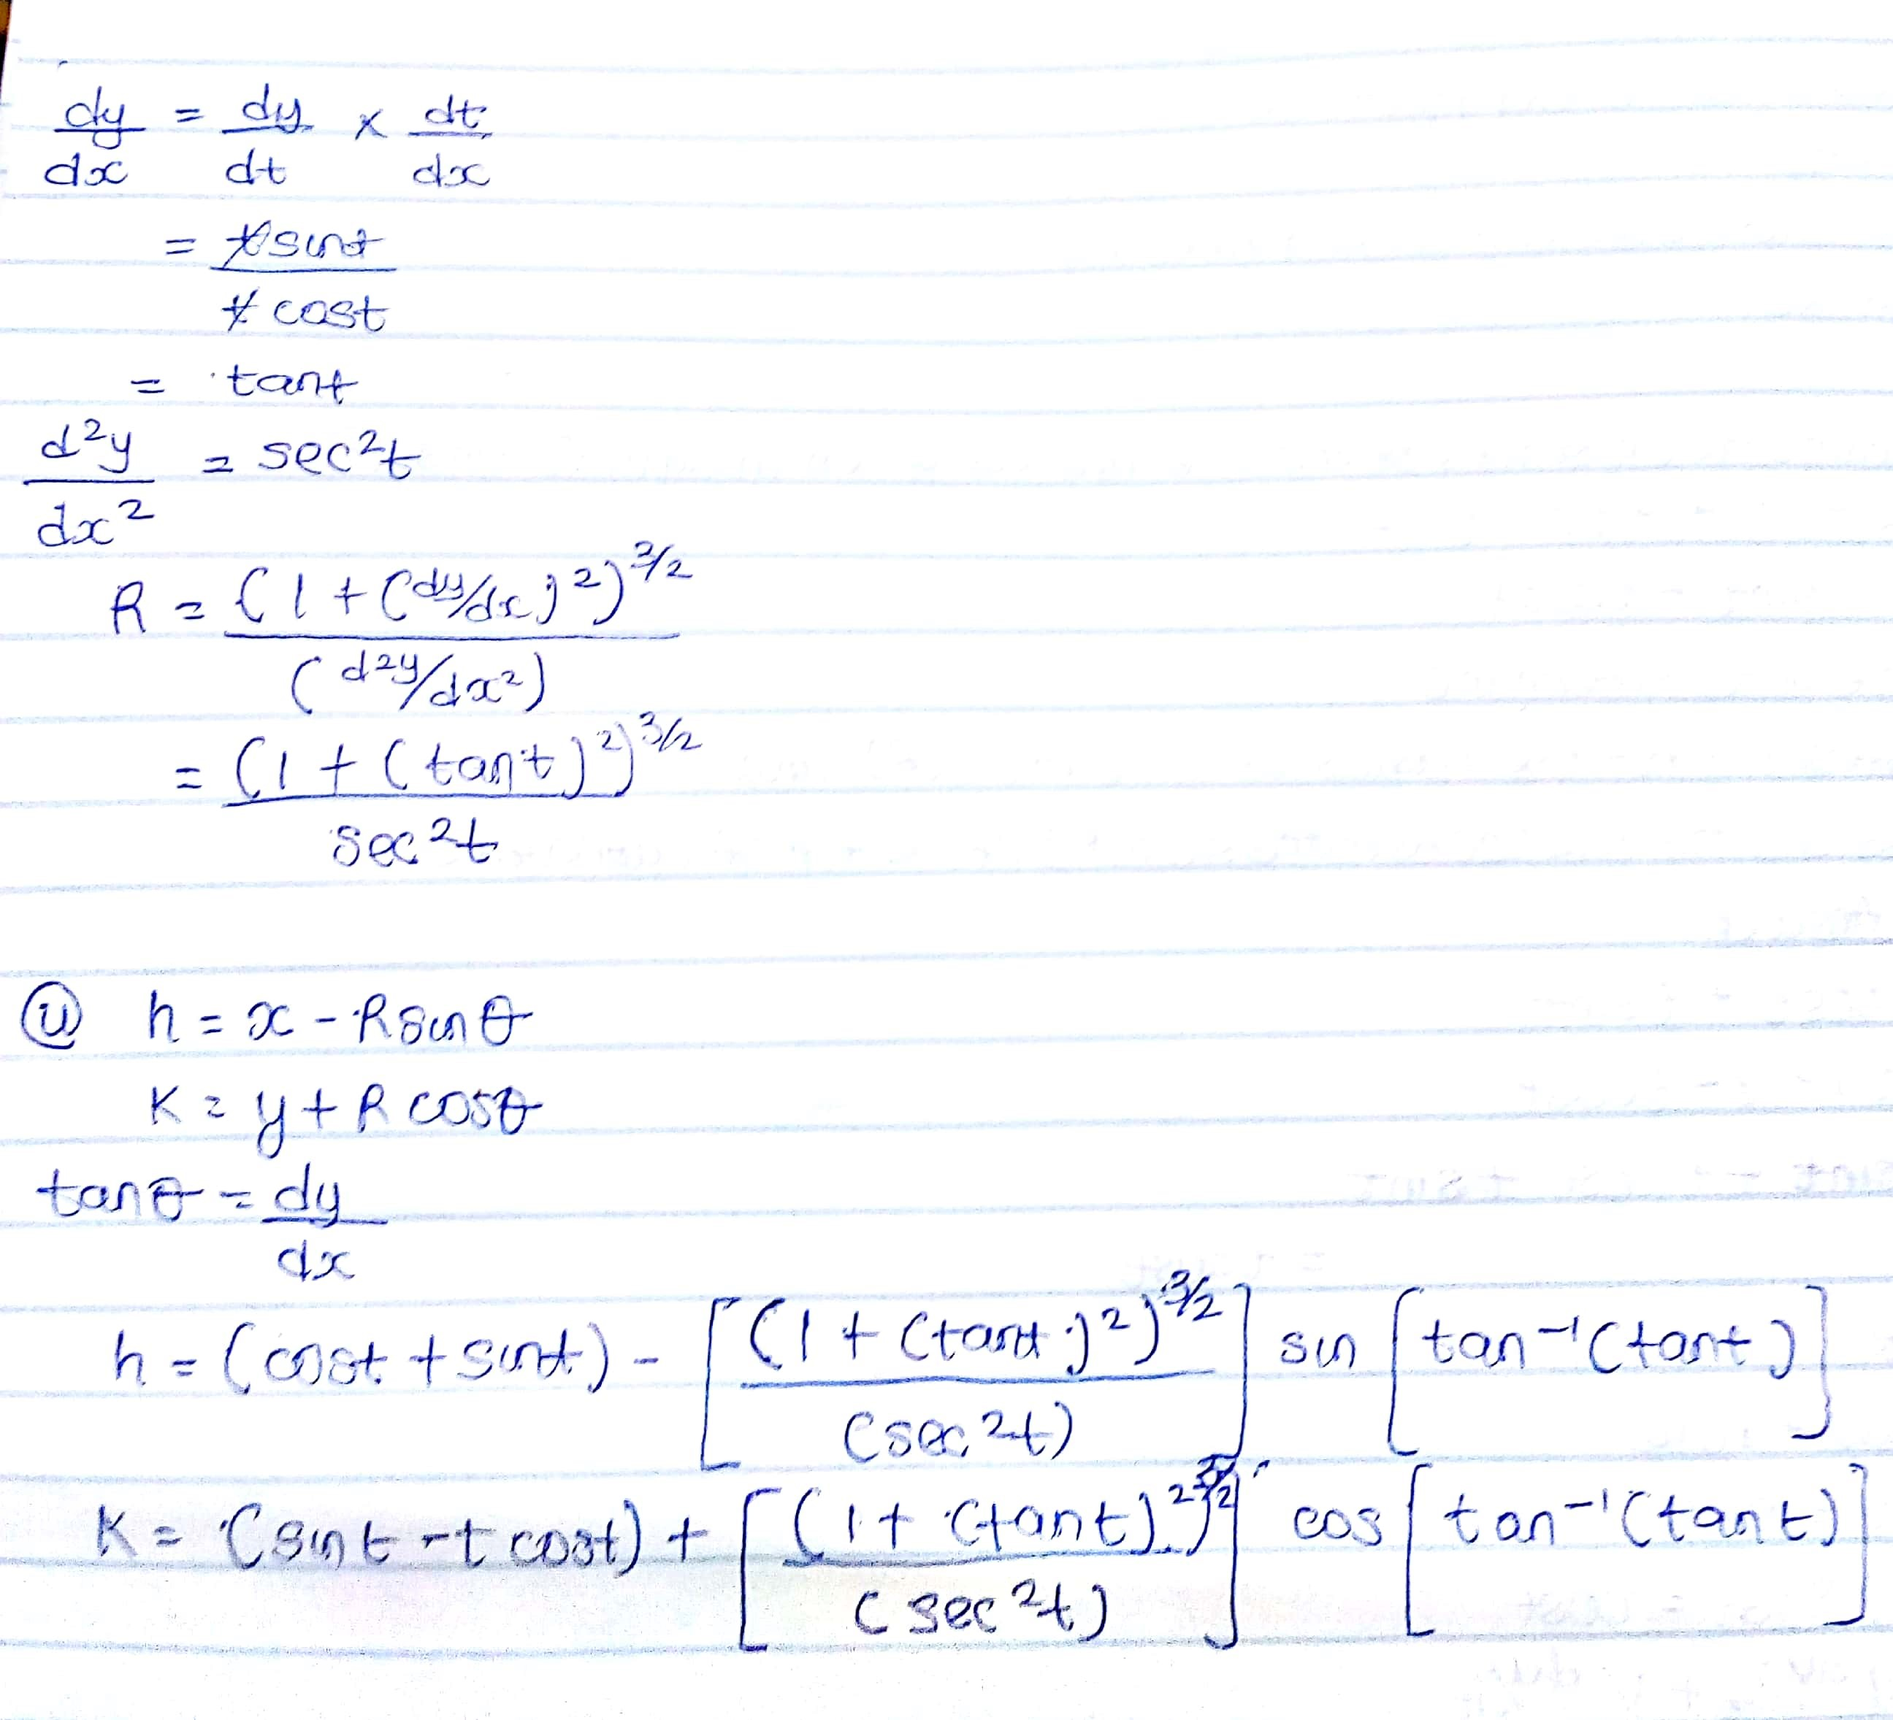
16/ENG04/052
ELECT/ELECT

